DaangVikas Sansthan.Karauli (Rajasthan)

Annual Report from 2018 to March 2019

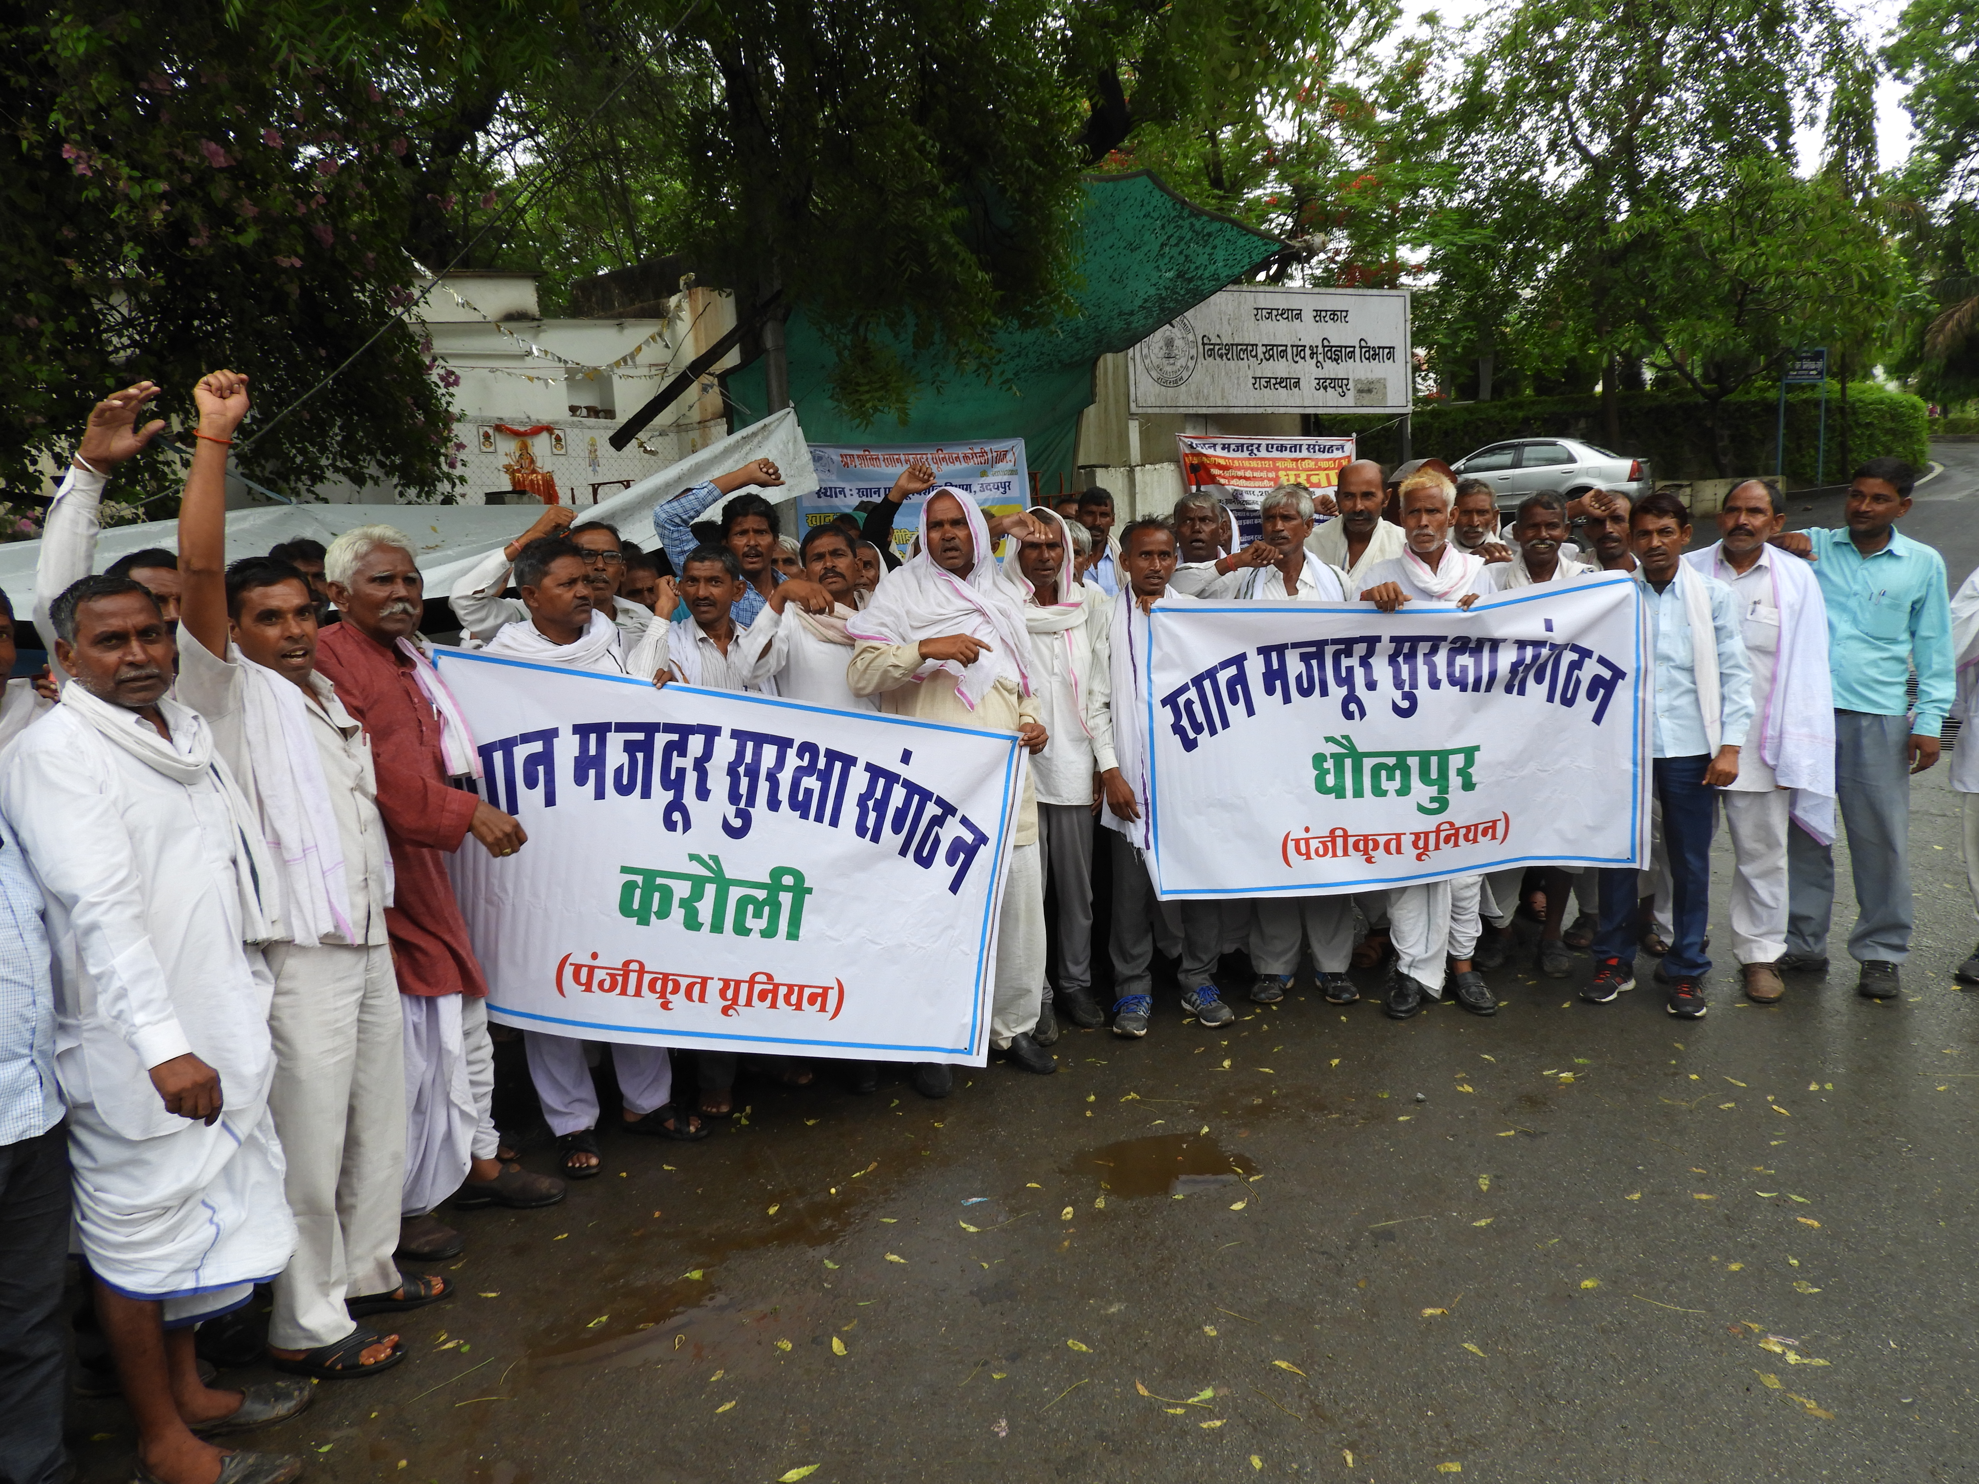

Support By -Paul Hamlin Foundation U.K. (P.H.F)
Activity Description
State Level Workshop
Experience Exchanges Workshop on safe mining of workers employed in stone cutting in the state level, dated April 18, 2019 in Swaraj Jaipur by Dang Vikas Sansthan, Karauli in which 10 organizations including 32 workers working in Karauli, Dholpur, Ajmer, Bhilwara, Bijaulia area Representatives of unions participated.
What is the safe mining prepared by the organization in the workshop that can be saved during the drilling by the device? What are the efforts of the government to protect the workers?
Presentation of the work, for the benefit of the labours, performed by the DaangVikasSansthan,. It was stated that the labours working from 2008, were informed about the risk of silicosis disease after examining the health of the labours and their lobbying was done to the state government. After the investigation of Silicosis done for more than 3700 labours in Karauli, Dholpur, Bharatpur and Dausa districts the certificate was madeand the amount of 40 crores was provided by the State Government for theirhelp. The organization is also working on the entitlement of labours. The organization has also been working for their prevention for the last two years in which a local-level device has been developed with all the measures of dust-proofing, such as watering, oiling etc., which has minimal cost and whose availability is also easy. It is being used by the efforts of the organization in ten mines of Karauli and 10 mines of Dholpur, out of which fifteen labours are participating in this meeting. The video clip is also shown in their presentation. It was asked by the participants, whether the sponge used in the device is kept wet or dried, on which, the labours working on that, told that it should be kept wet.
All the participants discussed this presentation, after which it was suggested that the use of the tool at large level and its study must be done. After training given by the workers of DaangVikasSansthan, it was used in three mines of Bijolia, follow up done and when succeeded, it is being using in ten mines. The organization has approached the mining engineers, taken order for all the mine owners, for the use of this tool. The organisation is working on ten mines for making it a Model Mines.
After this, the open session was organized - in which open discussion was done, regarding the queries of tool.
Question: Will this tool save from drilling nearby?
Ans: In that situation, this tool will not be having any effect. But it was told by DVS,that the demo is being done for the rescue of the drill.
Later, stone labourers used the tool in open ground, in which 50%, it was said to be effective on the dust.
Detailed report is being attached:
Connecting to government-run schemes:
In order to fill the application of Government Schemes, device was operated by selecting rural community fellows by Gram Panchayat, in fifty villages of Karauli and Dholpur district. In which 1450 applications were filled by the volunteers, the schemes run by Government for the deprived eligible families. After sorting the scheme wise need of letters and sending them in the respective departments, based on the follow-ups, the schemes has been linked as follows:
Sno. | Scheme’s Name | Number of benefited families
1. | Food Security Scheme | 280
2. | Bhamashah Animal Insurance | 40
3. | Domestic Electric connection | 70
4. | Widow’s Pension Increment application | 25
5. | Bhamashah Insurance Scheme | 56
6. | Clean India Mission | 102
7. | Prime Minister Accommodation Scheme (PMAY) | 80
8. | Application for silicosis pension | 70
9. | Online application for silicosis Screening | 250
10. | Silicosis help | 183
11. | Widow adoring scheme (Palanhar) | 24
12. | Apna Khet Apna Kaam and Cattle shed | 52
13. | P.M. A.Y.appeal | 567
14. | Labour department beneficiary registration application BOCW ) | 150
15. | Benefits of ShubhSakti scheme (BOCW) | 15
16. | Scholarship to children of labourers | 25
17. | Nutrition for pregnant lady and mother of newly born baby | 67

Organizing camps to connect with government-run schemes:
15 camps were organized in this quarter at the village level to link the mining labourers suffering from silicosis to the government's flagship scheme. By providing the information of government schemes at the village level, preparations for the following schemes of eligible mining families have been prepared and deposited in the government departments-adoring scheme, Clean India Mission, Prime Minister Accommodation Scheme, Apna Khet apna Kaam and Narega Cattle shed, Building and Other Construction Workers Registration and Food Security Scheme.

Organizing meetings of Core Group Members ofKhan Majdoor Surkya Sanghtahn :
DVS organized 12 meetings of Core Group members of Karauli and Dholpur Mining Labour Collectives . In the meeting, the report was submitted regarding the activities, in cooperation with the organization by the association. Sending potential silicosis patients to board, preparation of data of the members of the association, creating Identity letter of mining labours and regular discussions on necessary facilities at mines for labours safety by organizing regular meetings. And for safe mining, the following activities are selected:
- Demo of the safe mining tool prepared by the DVS
- Applying tools in 20 locations in Karauli and Dholpur districts.
- To promote the propaganda of the tool for safe mining in the mining areas of Karauli and Dholpur
districts.
- Put the first Aid kit on the workplace.
- Continuous contact with the mining owners to facilitate the necessary facilities such as water shade,
medicines, toilets, check safety systems at the workplace.
Silicosis Check-up and Treatment Camp:
DVS and District Tuberculosis Department organized camps for silicosis examination of stone workers of Karauli and Dholpur districts. In which after examining the mine workers, the potential silicosis patients were made online by the association for the board. Details of the situation from October 2018 to March 2019:
District | Total Registration | Pending on C.H.C | Pending in Medical Board | Rejected C.H.C | Pending Certificate | Pending at Nodal Officer’s Place | Pending in Labour Deptt& City council | D.M.F.T’s help | Deprived of help so far
Karauli | 5478 | 2637 | 1311 | 1437 | 5 | 84 | 4 | 151 | 873
Dholpur | 3557 | 690 | 246 | 144 | 2 | 60 | 10 | 284 | 127

To provide support to Silicosis Victims:
With the support of the District Mineral Foundation Trust, in collaboration with the State Government, prior to 435 Silicosis patients, 315 Silicosis alive patients of Karauli and Dholpur districts received a total ofRs 3 crores 15 lakhs and the assistance of Rs.360 lakhs was provided to the dependents of the deceased.

Basic level primary workshop:
Workshop on safe mining was organized by the organization with mining labourers of 30 villages of Karauli and Dholpur district.The demo of the tool was done to the mining labourers in the workshop, prepared by the organizationfor the protection from the dust and they were trained at the workplace. They appreciated the dust controller tool, which was prepared by the organization at no cost and were ready to use it.

The Silicosis sufferers and mining labourerswere invited by the organization, in the said workshop for consultation for the treatment by the District Tuberculosis Officer. They advised to take symptomatic treatment to the silicosis sufferers, take advantage of free medicines scheme.
Mine mining school:
After researching for the ten years, considering the felicitation of silicosis,formed the Mining Labour Union, for safe mining, 50 mine mining school are being conducted every month on “No Moon day”(Amavasya) at village level, by the organisation; in which continuously contacting with 5000 mine labourers and on the basis of labourers' experience, the tool has been developed to protect Silicosis by the organisation.With over 250 mining labourers working in 25 mines of Karauli, Dholpur, Bharatpur, Bijolia are using this tool, which have positive results.Dang VikasSansthanKarauli, working on the issues of the emerging danger of silicosis disease, ofthe mining labourers,widow women of mining labourers, the rights of workers working on crushers, their livelihood, development skills, empowerment and professional health-of 4 districts of Karauli, Dhaulpur, Dausa and Bharatpur of Rajathan.With the efforts of the organisation, the amount of about Rs.40 crores has been received by the state government in the said districts. Doing the above activities by the organisation, also the safe mining mechanism was told by the organisation to the mining workers but no positive results could be found.Masks were also distributed by the Department of Mines, talking about safety measures by the DVS as well at their level. Under the guidance of secretary of the Dang vikassansthan, the program coordinator Rajesh Kumar told that the workers of Karauli, Dhaulpur and Bharatpur districts are being trained to use it. Before the training demo of this tool was done by the employees of the organizations in the mines, for which the mining workers appreciated it and told it was a good effort. After that continuous training is being given in multiplicity mining districts of Rajasthan.The experienced training coordinator, Mr Rajesh Kumar, of the DaangVikasSansthan, will train to control the flying dust during mining to the workers of the ‘soft sand stone mines’, Ajmer and Bhilwara (Bijolia).This effort will be done by the organisation in the multiplicity mining districts of Rajasthan.
The District Mineral Engineer and District Collector told that the tool prepared by theDVS, is a commendable step and the organisation should promote its propaganda at the maximum. The special feature of this tool is-
- There is no cost involved.
- 60% of silicosis pulls the leads of the silica particles towards it.
- The content of the tool is easily found.
- Demand for this tool is increasing.
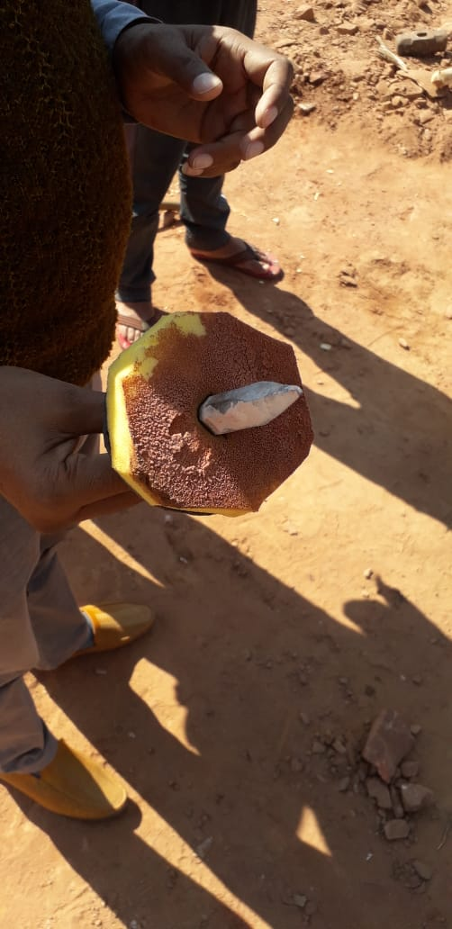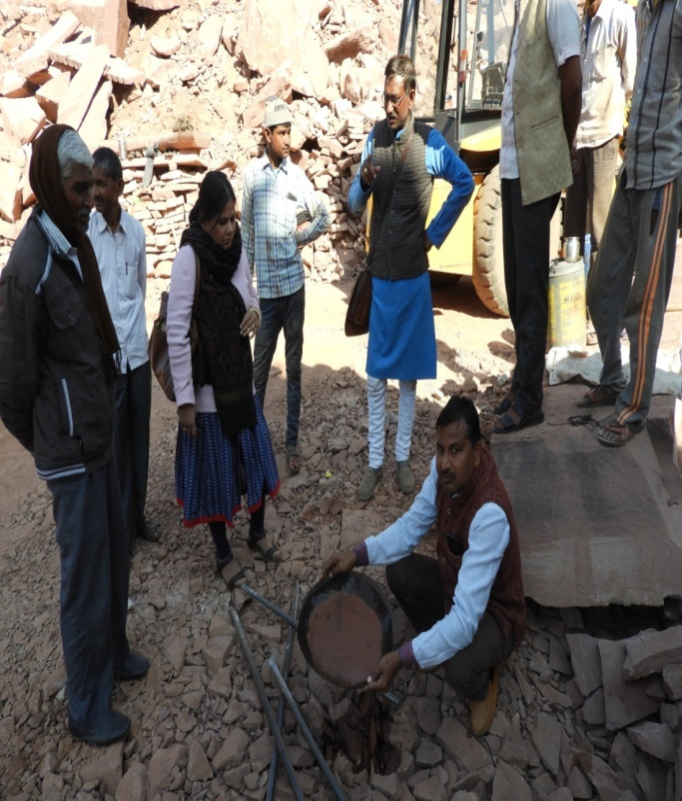

Lobbying for district, state and national level:
By lobbying to State Government, State and National Human Rights Commission and Honourable Supreme Court, financial assistance of Rs.40 crore was provided by the organisation to thevictims of silicosis mines workers, stone carving workers, 3730 poorest silicosis sufferer victims&the families of the dead. And for the assistance of 2500 labourers’ application is pending for that lobbying is under process.Besides, a petition for the formation of the Rajasthan Silicosis Rehabilitation Policy and Mining Labour Welfare Board has been filed in the State Government and Honourable Supreme Court.

Networking Meeting:
Meeting conducted by the DVS & in that the work done by the organization was discussed in detail with the NGOs connected with stone labourers’ silicosis and labour unions, it was explained in detail that the mining labourers in their own work area will be informed about the formation of the welfare board from the state government, the Silicosis Rehabilitation Policy, Silicosis Online Portal, as well as the information related to the government-run schemes will be provided to the general labourers.And regular check-up of mine workers of the area, silicosis check-up and treatment camps are organized every month in collaboration with the District Tuberculosis Department.Get the labours check-up there.And to inspire all labours regarding online applying for check-up of silicosis was discussedin the meeting. To improve the following points in the Silicosis online portal, need to discuss with the government-Details of problems encountered in Silicosis online:
- After doing online, victim need to wait for a month for the message. The message is sent late to them, as well as the Karauli sufferers are sent 50 kilometresfar away while the primary health center is also nearby.
- Along with the message the call should also be done to the victim for primary check-up and Board, and their time should be fixed.
- Appeal arrangements should be made in primary check-up and board check-up.
- The sufferer should be given complete result what is the disease, why it is rejected of both the levels i.e. the primary and the board level.
- The result of primary check-up and board check-up can be given in two days; no results are given for the month now.
- There should be arrangement in the portal regarding support for alive and dead, in this regard; there is no arrangement in the portal.
- There should be arrangement of all prior Silicosis certificates to be uploaded before online on the portal which is not available.
- Update must be available on portal from going online to provide support to the sufferers.
- For the help of the alive and deceased, application should be available on the portal of the Labour Department and the Department of Mines online, which will be then easy to apply.
- The certificate should be uploaded on the portal within two days of board, so that can be apply timely in the victim's assistance and the exact time should also be set for help, which can be found only on the portal.
The discussions about the safety, security and rights of Silicosis disease were done with NGOs of Jaipur, Bundi and Udaipur in Rajasthan, including workers working in union & mines, along with National and International organizations,stakeholders involved in stone business.In which discussions on the activities of the Safe Mining Silicosis Rehabilitation Policy, bonded labour, District Mineral Foundation Trust, and agreed to lobby a forum with the state government, which will be continuously follow-up.
I.E.C.:
In collaboration with Paul Hamlin Foundation, with slogans of rescuefrom silicosis, tool demo on safe mining has done onreaching to the work place of mine labourers and for information related to government schemes; slogan writing has been done for Government Schemes and forrescuefrom Silicosis in 30 villages.

Block Convergence Camp:
Block convergence camp has imposed by the organization to connect the mining workers’ families and the widows of the mine workers to the government-run schemes.In which it has been told by Dr.MunshilalMeena of the Animal Husbandry Department about the Bamashah Animal Health Insurance Scheme& the Government-run Animal Husbandry schemes of the Goat rearing Mines Workers Widows of Dang VikasSanstha, Karuali, that 10 goats count as one unit, whose insurance is done on very low premium, in which it contains one year insurance. If the goat dies, it is highly essential to have a post-mortem by the doctor, so that the goat rearer can get a claim, this should be taken care. He explained in detail regarding thedocuments which is required forthe animal husbandry insurance.Also, detailed information about timely vaccination of goats and the prevention of seasonal diseases has been given.

Veterinary Camp:
Meeting with Goat Treatment Camp and Goat herder has been organized by DaangVikasSansthan. 150 goats has been given vaccination & treated for fever, cold, diarrhea and dibmirgby Dr.MunshilalMeena of Animal Husbandry Department, in the villages of the area KosraSuraiya and KoteChabar and Machi were treated,in addition to this, provided information about the maintenance of goat rearing to the cattle keeper, he said that timely vaccination of goats can save them from the outbreak of seasonal diseases.And the goats have worms in the stomach; they need to be de-worming every 3 months for their survival, which will not cause worms in the stomach.

Keep the goats in a dry place, so they will not get sick and it is very important to take care of goat's diet-in which adding corn flour, jaggery, salt together in dry grass, and feeding Acacia leaves, Ficus leaves etc. the goat will always be healthy. He told that keep goats always on perch because goats likes to stay on perch. And it is necessary to give goat pure water, which will not lead to stomach disorders. He said that goat rearing is such a task to earn more money in low cost, but it is very important to maintain it.Told that goat’s milk is very strong, it protects humans from many diseases. And the goat rearing increases the income of the family, giving a lot of support to the poor families. And goat rearing in Daang area is good for livelihood.

Entry into software:
Entry is being done in the software of the mining labourers of Karauli and Dholpur districts by the organisation. Entries of 7880 members have now been done. And the government-run schemes are being tracked in the software.

Check-up Camp for silicosis of Building and Other Construction Workers:
In collaboration with the Department of Labour, Rajasthan, in the districts of Karauli and Dhaulpur, the camps has been organized in view of the silicosis horrifyingness in stone construction workers and stone carvers.In which registration of 495 workers done, out of which 212 workers are found in different categories of Silicosis, the check-up is done by Dr P. K. Sisodia, a business health expert of the Labour Department in camp.

Youth Mine Workers Enhancement Meeting:
The meeting has been held for the information regarding the rights of labourers, the problems of labourers, silicosis check-up, treatment and safety in the villages of Karauli and Dhaulpur district &in 25 villages which will be used for labour to create a welfare scheme, for that lobbying will be done to the government.

District and State Level Silicosis Tasks and reviewmeetings:
In the Task Force meeting at the State and District level, issues related to social security schemes, investigative treatment and aid issues are kept by the organization for the welfare of the Silicosis victims and the widows of the mining workers.During the quarterly meetings presiding by the Health Secretary, to sort out many issues arising in support and check-up by the organisation:

- Formation of pneumoconiosis board in Dholpur.
- Work Certificate from labours & from mining owners in support.
- Post-mortem report from Dr and from the dependents of silicosis dead.
- Potential silicosis patients are not getting on boardtimely.
- Due to delay in help dying without getting assistance.
- To start online process for board and assistance.
- Formation of Mining labour Welfare Board.
- Concerted efforts by the government for safe mining practices to be done.
- Silicosis Rehabilitation Policy should be made only in Rajasthan on the lines of Haryana and Madhya Pradesh.
The above issues were discussed in detail, in which the government has agreed the consent of the above points.
Formation of Silicosis Board:
Patients are not being examined due to lack of board in Dholpur district, the pneumoconiosis board was formed in Dholpur district by the organisation lobbying at the state level.

Meeting with media:
District level media workshop has organized to make aware the district and state government through newspapers about the problems of the mine workers by the organization.

Staff Capacity enhancement training:
Activity of all staff of DaangVikasSanstha from 2016 to December 2018 has been reviewed and the next action plan has prepared whose detailed description is as follows:

Sno. | Activity Description | Month | Workspace
1. | Application for Silicosis check-up - To Consult the Workers | January to December | Karauli and Dholpur
2. | Connecting the eligible familiesto schemes, deprived of government schemes | January to June | Karauli and Dholpur
3. | Block Convergence Camp | January to August | Karauli and Dholpur
4. | Silicosis I.E.C. 25 and more than 25 members in a village | From January to March | Karauli and Dholpur
5. | Health awareness program - Mother health, infant health and reproductive health (preparation of survey form) | January-March | Karauli
6. | Center for silicose issues-constitution of the center, operation and preparation of guideline | January to February | Karauli and Dholpur
7. | Labour Legal Awareness Workshop-making self-understanding of labour laws, and marking reference groups | January-March | Karauli and Dholpur
8. | Coordination with Panchayati Raj organisation-making self-understanding | March to April | Karauli and Dholpur
9. | Preparation of community reference, person training module | February | Karauli
10. | Awareness on Safe Mining-Selection of 20 villages | January- February | Karauli and Dholpur
11. | Tools demo and providing information to theemployer, sight visits, state level lobbying, tool material supply, experience sharing training, meetings with the school and families on safe mining and night Chaupal with workers | January to December | Karauli and Dholpur
12. | Silicosis prevention- preparation of the baseline of drug de-addiction, women's organization, nutrition etc., preparation of questionnaire | January to June | Karauli and Dholpur
13. | Connecting widowed women to government schemes like Narega registration, pension and pension increment office etc. | January to June | Karauli and Dholpur
14. | Meeting with mineralogist and networking meeting-issue based | January to December | Karauli and Dholpur
15. | Cattle Feeder selection and Enhancement-Vaccination, First Aid and Animal Protection Insurance | January to February | Karauli
16. | Participating in district, state and central governmental and non-governmental meetings | January to December
17. | Information about the current condition of Bhamashah health scheme and free medicines scheme and deliver to the reference community | January to March | Karauli and Dholpur
18. | To study the problem of farmers of the area and to identify the process of selection of farmers through KrishiVigyan Kendra - from Internet, R.T.I. | January to February | Karauli
19. | According to the list of Prime Minister housing scheme, adding the reference group and follow-up tag of previous work, following-on the bills of officers training. | January to February | Karauli
20. | Information about the villages coming in the water self-reliance scheme and the water uptake, and the irrigation department's plans. | January | Karauli
21. | To take Map of geographical area of district and block | January | Karauli
22. | Environment- plantation in the mining area, to gather information related to decantation of mining waste from mining department and forest department | February to March | Karauli
23. | Silicosis assistance - Selection of the area which is deprived till now, connecting missing sufferers with assistance, making strategy of work | January | Karauli and Dholpur
24. | Discussion points in the organization core group–In organisation review,reforming of Financial Program Management Enhancement and forming wafer core group, discussion on the awareness of LokSabha Elections | January to March | Karauli
25. | Capacity Development Training -staff, organization, labourers, educational tours as required | January to December | Karauli and Dholpur
26. | Survey of migrant labourers working in Sand Stone-preparation of questionnaires | January to March | Karauli
27. | Disability survey-preparation of survey’s questionnaire for workers interrupted with body part for 2 years, body disorder, dwarf, blind, dumb, deaf | February to March | Karauli
28. | F.L.R.C.Tool Training | January | Karauli
29. | Preparation of candidate-qualifying at least eighth from the reference community | January to February | Karauli and Dholpur
30. | Connecting with the objectives of Organisation-To addGovernment schemes with human policies in objective no.2 and to add professional health hazards and verifying it with from the Registrar. Take action on legal proceedings time to time. | January | Karauli
31. | Documentation - monthly, quarterly, half yearly, Yearly, procedural, case studies, effective documentation, new project creation, survey study compliance and follow-ups | January to December | Karauli and Dholpur
32. | Technical Education-improvement of animal breed and promoting wormycompost | March | Karauli
33. | Surveying Folk Artists in Rural Area | January to February | Karauli
34. | Surveying of deprivedchildren from school and AnganwadiCenters | April | Karauli
35. | Preparation of churningreport | January
36. | Accounting work | January to December | Karauli
37. | Data entry software | January to April | Karauli
38. | Calendars distribution | January
39. | P.H.F. project review and submit new project | May-June | Karauli

Capacity enhancement workshop on labour laws:
Information on organizations on labour law, mininglaws of staff andunionsrepresentatives, bonded workmen compensation law, minimum wages act Manrega law, laws of essential facilities etc. on the workplace, given by the representative of theAajeevika bureau..
Gradual hunger strike of silicosis victims:
Under the guidance of DaangVikasSanstha, indefinite strike has imposed on the following demands of the unions of Karauli and Dhaulpur of mining labour protection organisation:
- Relief fund should be given at the earliest to the silicosis victims and the dependents of the dead which is pending since 2016.
- Disbursement of Rs.1 crorewhich was sanctioned in December should be releaseat the earliest.
- Silicosis deceased who have received 3 lakhs, they will be given1 lakh more.
- Members of union and organisation should be included in the District Mineral Foundation Trust.
- Two lakh rupees are given by the Labour Department to the surviving silicosissufferers;the Department of Mines should also givetwo lakhs to the sufferers.
- Silicosis sufferers should be included in the category of disabled.
- Work should be given as per the efficiency of the Silicosis sufferers in Manrega.
- According to the guidelines of Pneumoconiosis Board, results should be given in 2 days after check-up.
- Offline certificates of silicosissufferers made in the past should be made online.
- Families of silicosis sufferers should be included in the Prime Minister's Housing Scheme.
- Relief fund should be given within 1 month after the certification of silicosissufferers.
- Should create welfare boards for unorganized sector mining labourers.
- Mine labourers should be insured by the government.
Considering the above demands in 3 days, the District Collector,after discussing with the representative of unions, accepted the demands on district level, of disbursement of Rs.1 crore, which has been given to the sufferers and demand letter has been sent for assistance of Rs.11 crore to the state government for pending applications. Demands has been sent on the state level and been assured that it will be fulfilled. For all this work, the same is being followed by the member of the Labour Security Organization.So far,PrabhuDayal of the Mining labour security organisation, who is also a Fellow in this program, has met the District Collector thrice, met Chief Medical Officer, Karauli and met five times withDistrict Tuberculosis Officer along with other members of the Union and labour problemslike online assistance, start application and to start the online process of making certificates which are made from 2014. The members of the unionalso met the Mineral Engineer, Karaulithrice. Similarly, Dholpur district union worked together with Fellow, which is a step towards continuation of the struggle of mine labourers. Facilitation is provided to them by the organisation and monitoring of work is also done.
Nutrition Survey:
The organisation is getting information of 30 villages of Karauli block, from 0 to 6 months, from 7 months to 3 years, from 4 years to 6 years, and ‘new mother’ and pregnant women vaccination, check weight, nutrition etc. By the end of May, 30 village health and nutrition reports will be presented.

Visit of Ms.Gajala, P.H.F. Representative:
In DVS with collaborationwith P.H.F. operative activities are reviewed according to plan and from the work done in the field, the beneficiary families found from which includes connectivity to schemes in villages of Guvreda, Mahu.In making a strategy on safe mining and overall development of the village,how many families are benefiting from pond construction in Mahu. Similarly, work should be done in other villages for which irrigation department will be linked with water sand and P.HE.D,Manrega etc. and should be done in other villages.In this regard, the organizationprepared map of Karauli and Dhaulpur districts and identified the issues. After taking information from departments,proposals are being made in Gram Panchayat, Bar Panchayat. Continuous follow-up will be done after election code of conduct.

Two-days training workshop on safe mining:
500 mininglabourers has been prepared by the DVS,training of dust control equipment is given and one daya demo has been given to mine labourers at the workplace, now the mining labourers are using this device from Mamchari, Mahu, Mandhili, Rajaur, Machet, Kosra and Sourya villages of Karauli and Bhindipura, Rehrai, Padampura, Barauli of Dholpur. And told that the tool has a lot of advantagewhile praising it, less dust goes inside it, it stops if eye get injured, do not hurt in the hand. It is being used by the mining labourers of Karauli and Dholpur districts. There is no cost involved in this tool and can be made easily. It’sdemand in labourers is increasing.

